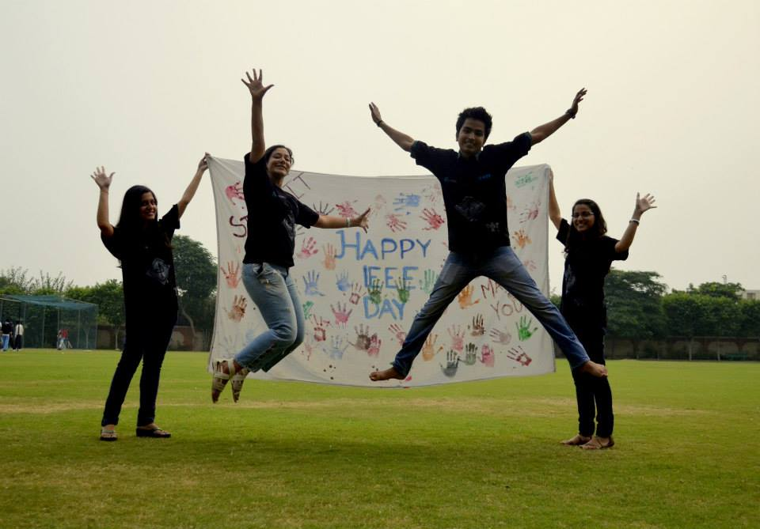

IEEE Day 2013 was zestfully celebrated in our college on 1st of October to mark the anniversary of the day when IEEE members from all over the world gathered to share their technical ideas. With members, non - members and the executive team being part of the celebration, the event saw a huge turnout. The event spread the word of IEEE among freshmen and induced participation of students from all departments. Students showed their contribution by participating in the Hand Painting event organised on the day. Banner highlighting “IEEE DAY” was decorated with hand prints of enthusiastic students of the college. To show our exuberance on the day and pride to have IEEE chapter in the college, we also participated in 2013 IEEE Photo Contest. The main aim of the event was to celebrate the important day of engineers while initiating and motivating the students towards this plethoric technical organization. This year the theme of IEEE Day being “Leveraging Technology for a Better Tomorrow”, our student branch did the needful for the betterment of environment and humanity by hosting an opinion based contest. Student members were encouraged to kindle the fuel of engineering and propound ideas that shall leverage the advancing technology for energy conservation. The BVP-IEEE Entrepreneurship Cell paved the way from prototyping to commercialization, thus giving birth to a new start-up! A drop box placed in the campus gathered what innovative young minds came up with and the participants got to brag about their contribution by leaving a hand print on the BVPIEEE Green Wall!

IEEE is a marvellous organization which brings together technical minds; we feel privileged to be a part of the organization. The day symbolizes the importance of developing technical and professional skills, as being evident from the celebration of IEEE Day.